**CORS Configuration**

Create a bucket by unchecking **Block all public access** , enable static website, add bucket policy and add index & error html files

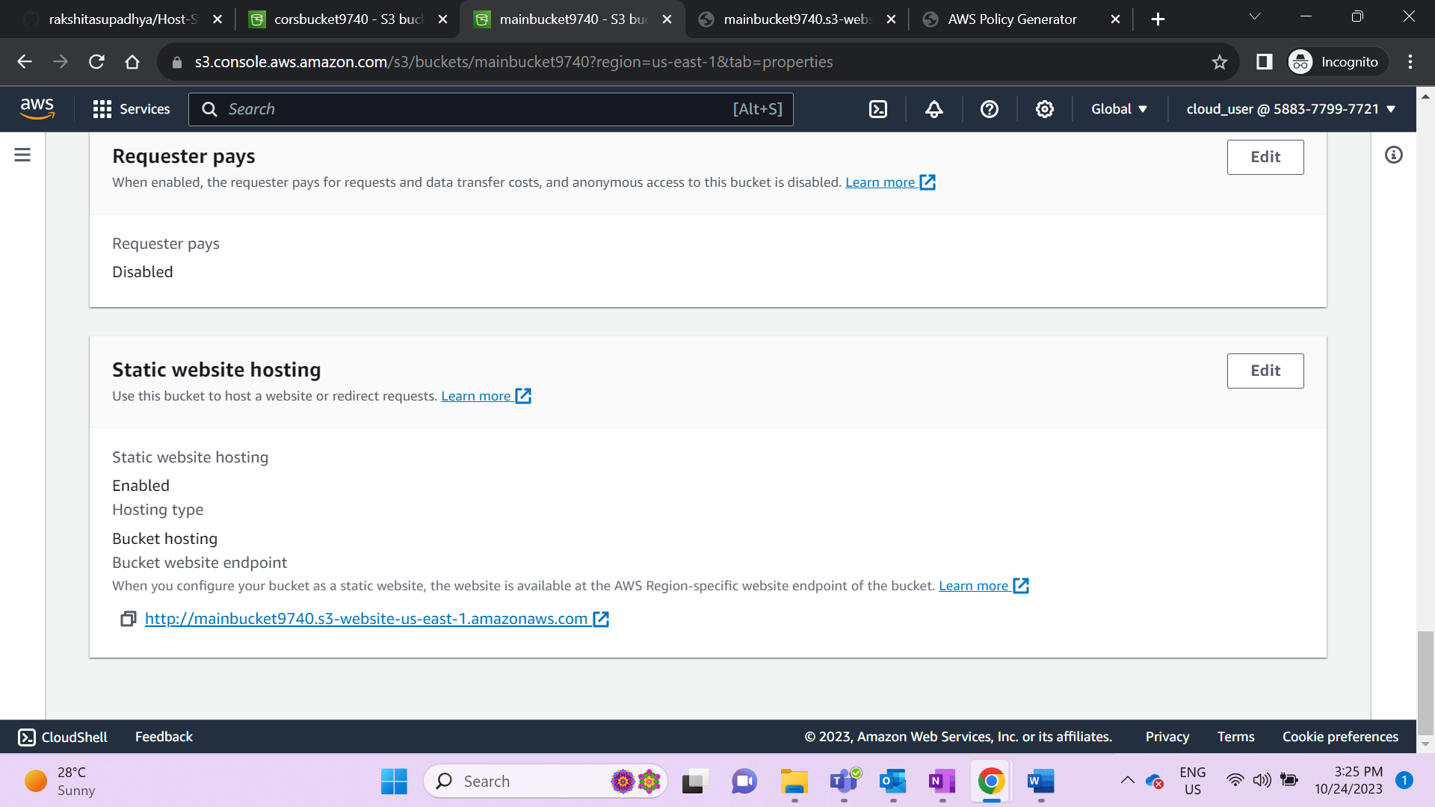 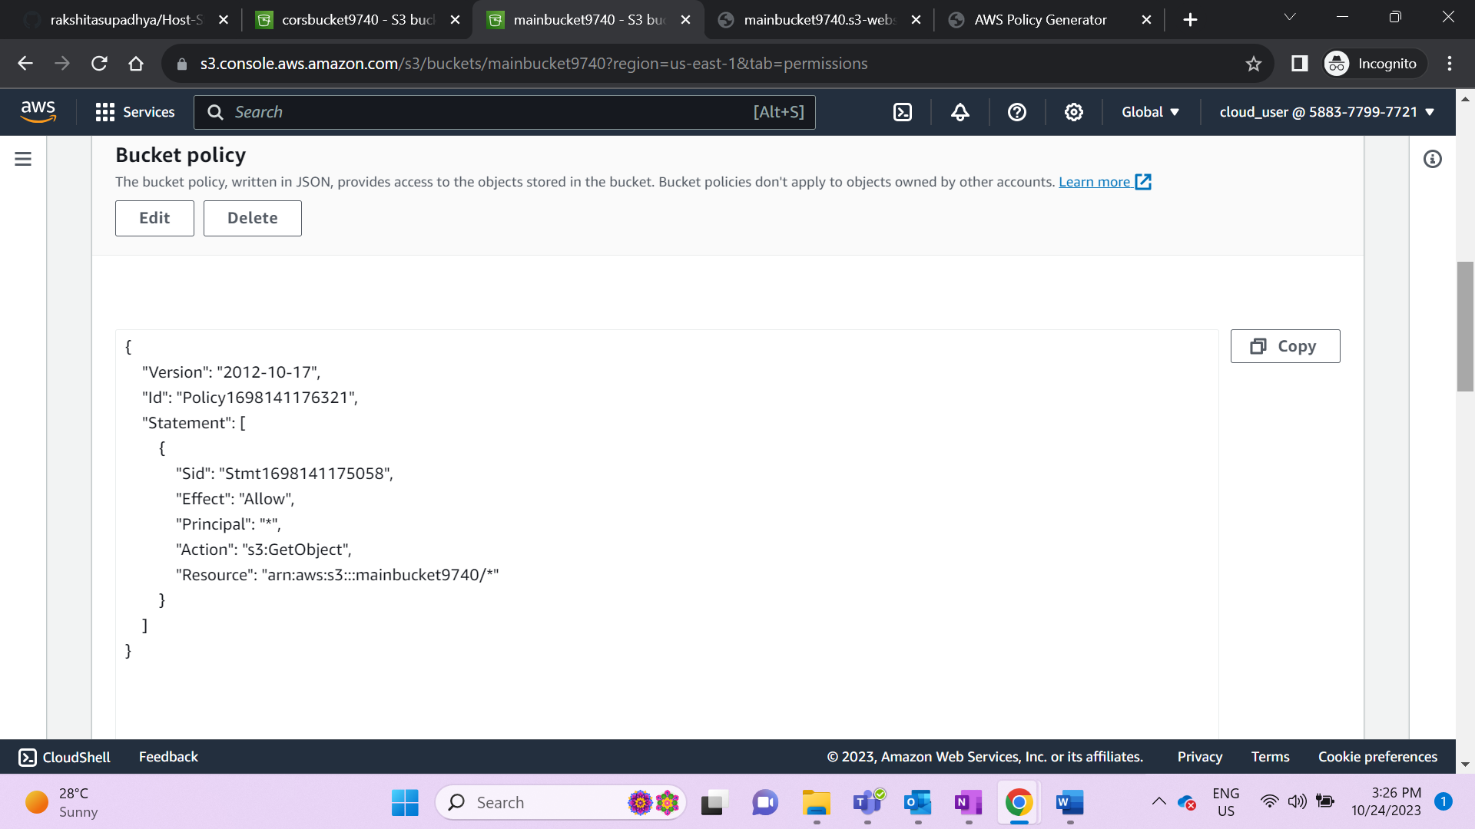 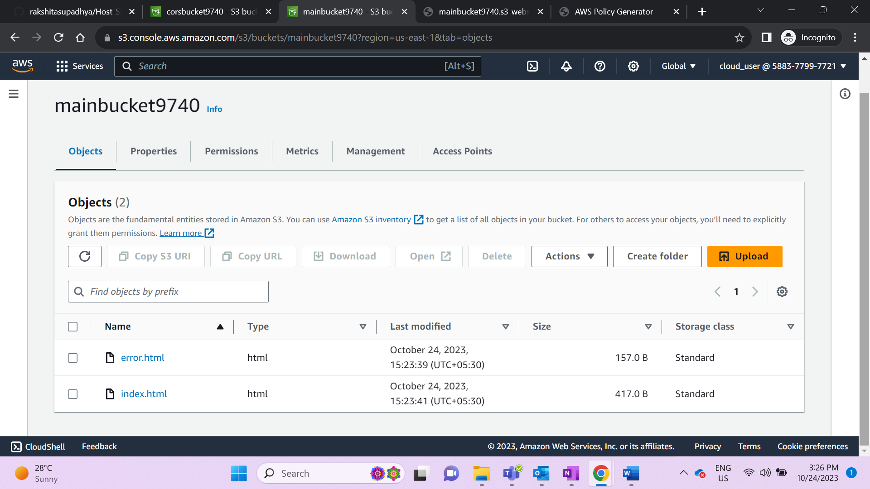

In index file add the static website URL of cors along with <file.html> and save it

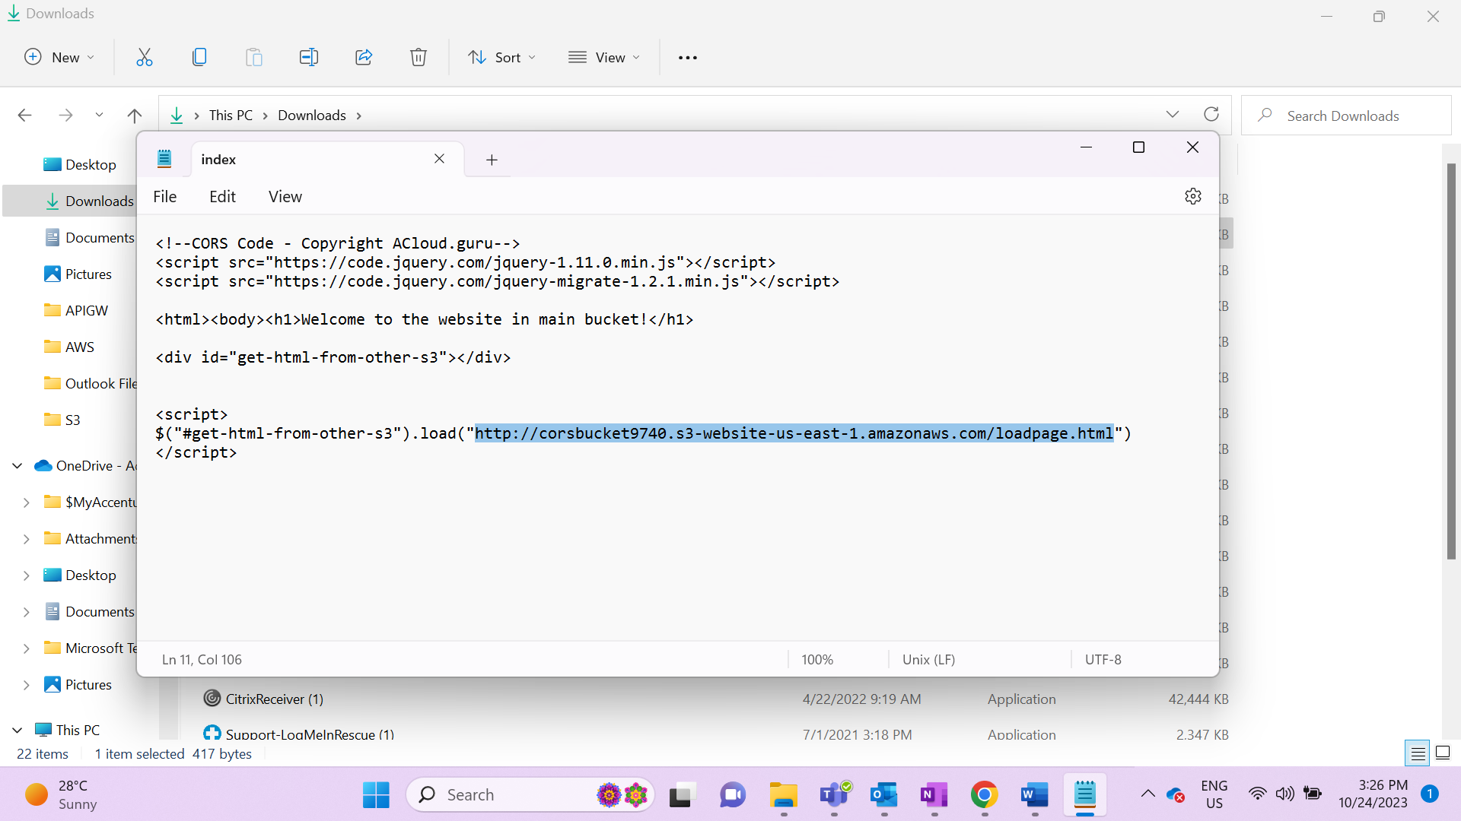

Create a bucket , enable static website and add loadpage & error html files

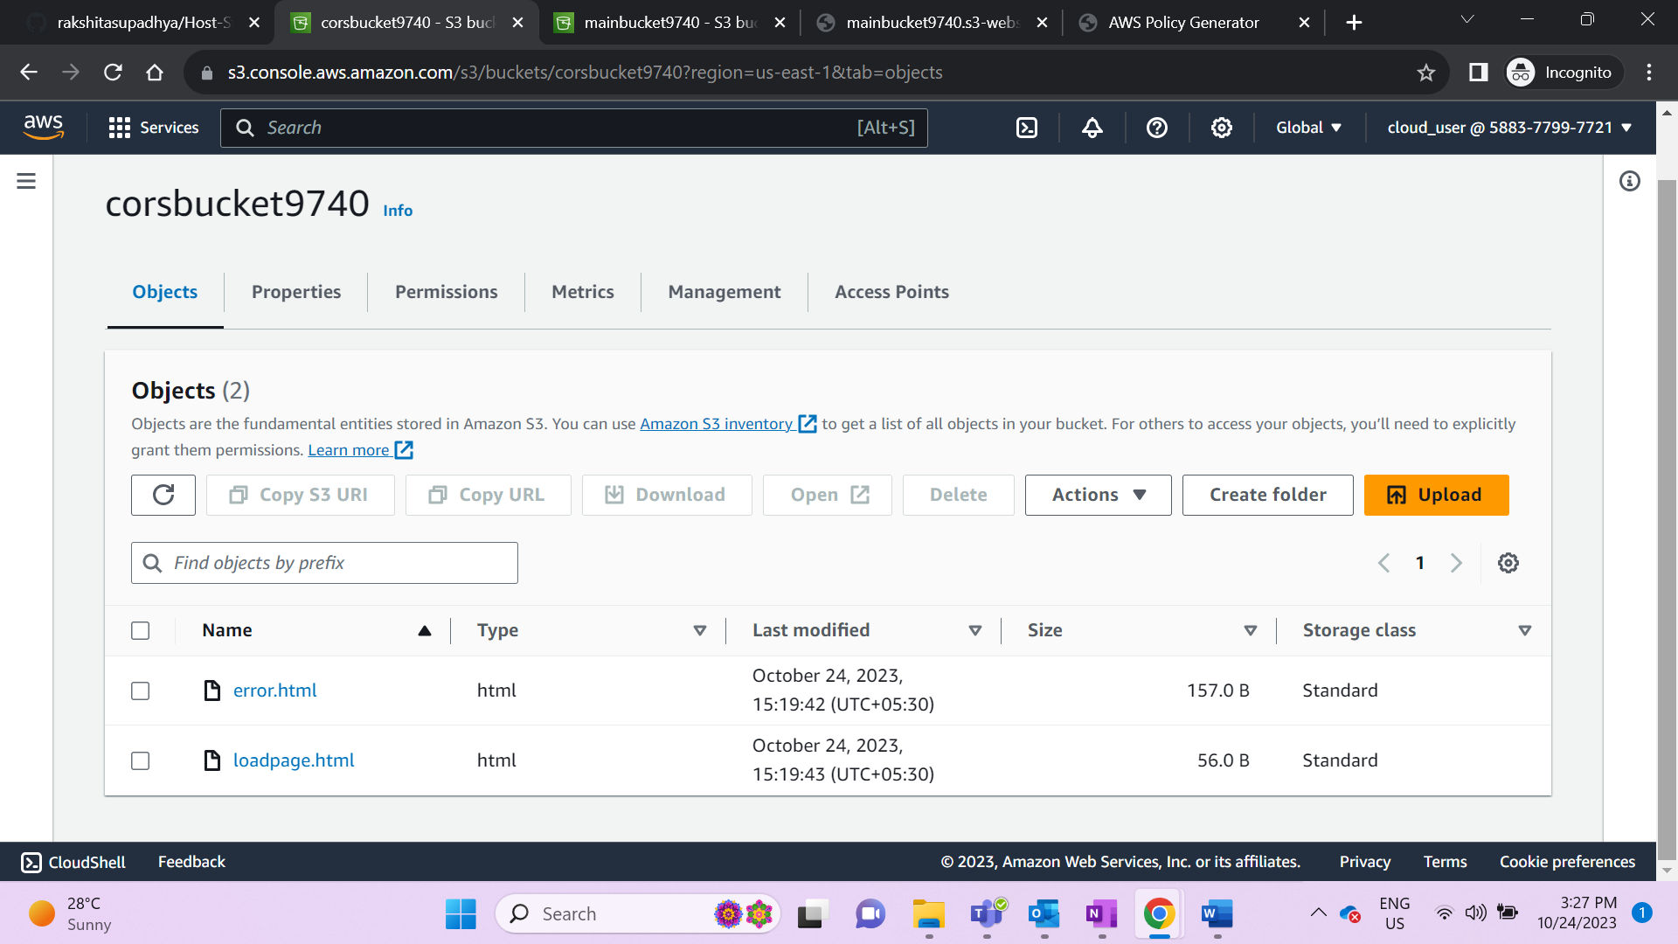 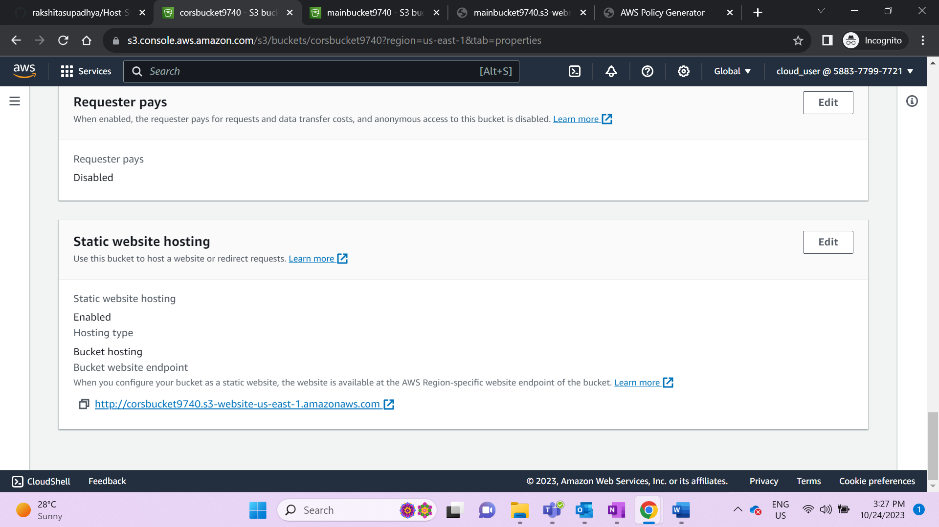 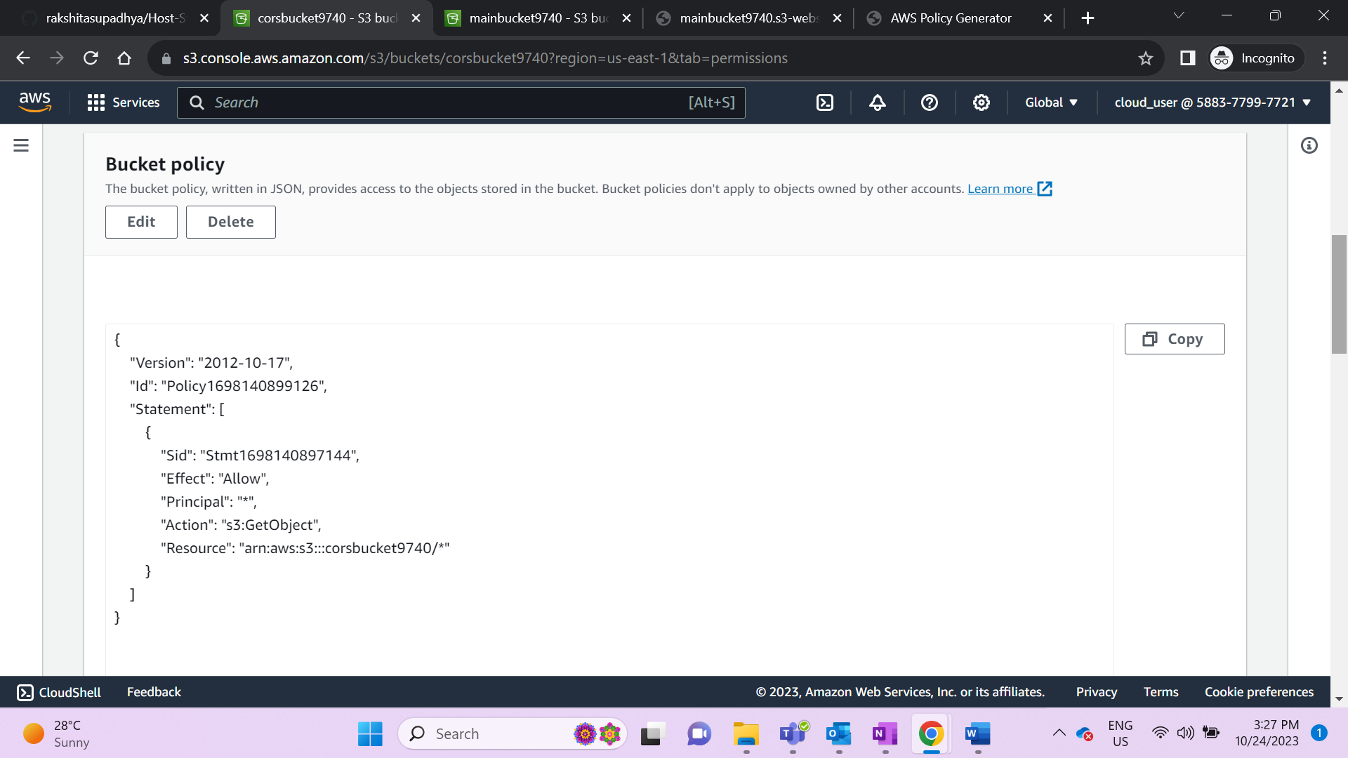 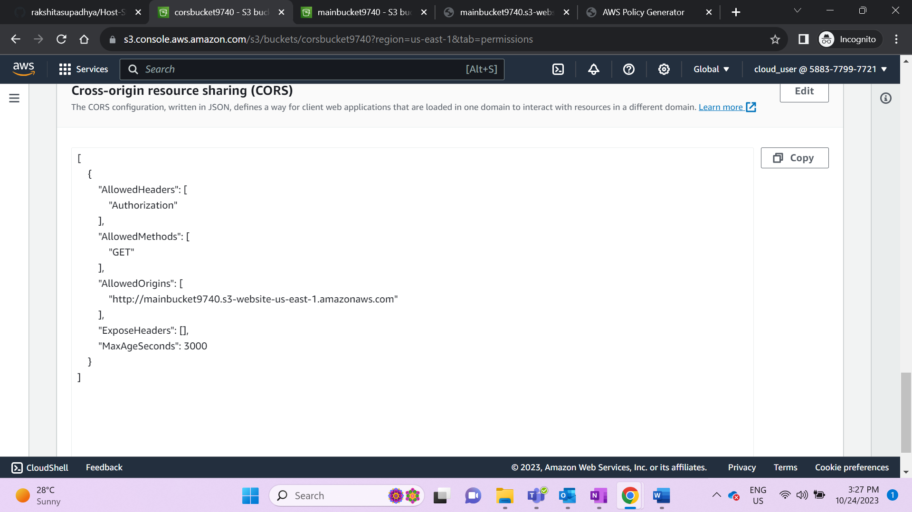

Configure CORS in the bucket which has the file that other bucket is trying to fetch

[

{

"AllowedHeaders": [

"Authorization"

],

"AllowedMethods": [

"GET"

],

"AllowedOrigins": [

" http://mainbucket9740.s3-website-us-east-1.amazonaws.com"

],

"ExposeHeaders": [],

"MaxAgeSeconds": 3000

}

]

When static website is hosted both index & loadpage contents are displayed on the website

